TOOK IMAGES OF THE SCREEN , SINCE THE MY SYSTEM HAD A PROBLEM WITH SCREENSHOTS
Data used :
Id name
1 United States
2 Canada
3 Mexico
4 France
5 Germany
6 India
7 China
8 Japan
9 Brazil
10 Australia
Mapping Screenshot:
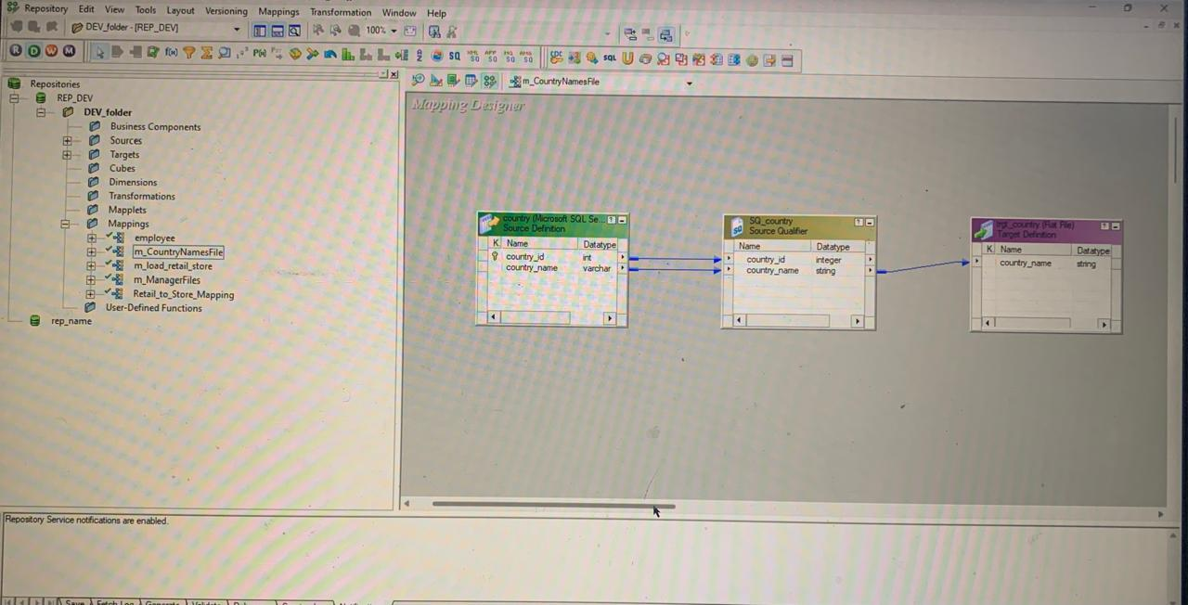
Workflow Manager screenshot:
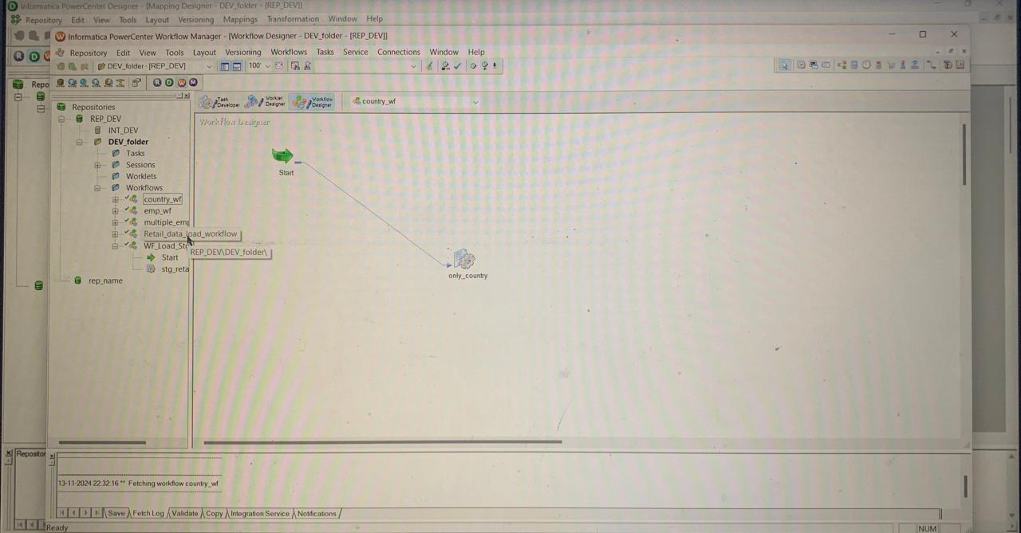
Workflow monitor screenshot:
